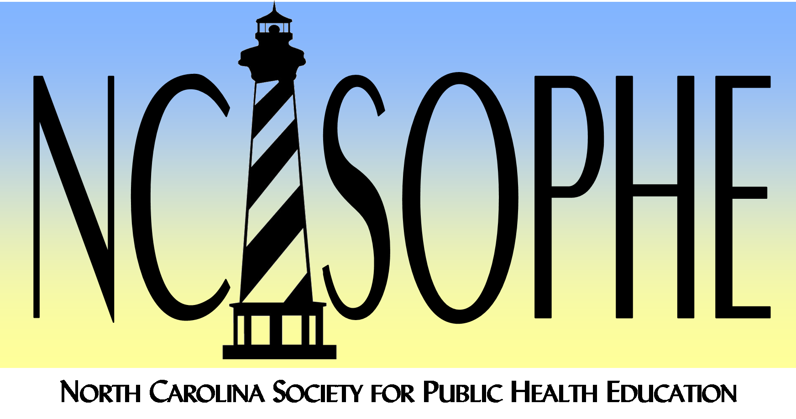

2021 NC SOPHE Annual Scholarships
Undergraduate & Emily T. Tyler Graduate Scholarship
Application Guidelines

The NC SOPHE Annual Scholarship Award and the Emily T. Tyler Academic Scholarship Awards are one-year scholarships in the amount of $500.00 for a NC SOPHE member who is actively enrolled in a health education undergraduate or graduate degree program (or related field). Determination will be based upon the eligibility criteria, selection criteria, and a complete application package.

- Eligibility Criteria: To be eligible for the award, an individual must be:
  - A CURRENT, dues-paying member of NC SOPHE as of the date of application.
  - Pursuing an academic degree in health education or a closely related field at the baccalaureate, master’s or doctoral level during the 2021-2022 academic year.
  - Actively involved in the practice of health education or participating in academic health education activities, projects and/or research (performing health education activities at a professional level of competence).

- Selection Criteria: Criteria for selection are as follows:
  - Show promise of making a significant contribution to the professional practice of health education in North Carolina.
  - Has been involved in health education activities over the past three years (if appropriate, school transcripts may be requested).
  - Preference will be given to the applicant who:
    - Has not received the award previously.
    - Is attending a North Carolina college or university.
    - Is enrolled in a health education program.
    - Has been actively involved in the delivery of health education services.

- Application Package: To be considered for the award, applicants must:
  - Application Form: Complete and submit the application online at NCSOPHE2021ScholarshipApplication.
  - Obtain Three Recommendations: The recommendations should be from individuals familiar with the professional and/or academic skills and abilities of the applicant. Each person providing a reference should complete recommendation form online at https://tinyurl.com/2021SCHOLARSHIPRECOMMENDATION. Recommendation forms must be submitted by the person making the recommendation. Recommendations will NOT be accepted if submitted by the applicant.
One recommendation must be from a current member of NC SOPHE.
- One recommendation must be from a current member of NC SOPHE.
- One recommendation must be from a professional supervisor or, if the applicant is a student, from a department chair of the school in which the applicant is currently enrolled. The recommendation from the department chair must include a statement that the applicant has been accepted into a degree program and is currently working towards a degree.
- One recommendation must be from a co-worker, professor or community member who has worked with the applicant on a health education project.
  - Deadline: The completed application packet, including recommendations, must be received by August 28, 2020 at 5:00 pm.

- Notification of Scholarship Recipient: A letter will be sent to the scholarship winner and the winner will be presented during the Awards Section at the NC SOPHE 2021 Annual Meeting held virtually November 4-5, 2021. The scholarship recipient will receive the check in the mail. Checks will be mailed to the address provided in the application. We strongly recommend attendance to the NC SOPHE 2021 Annual Meeting.

For questions or additional information, please contact the Awards Committee at northcarolinasopheawards@gmail.com.

